STANDARD OPERATING PROCEDURE — Acetone Permeation Test

Material/Company: Monneah’s Engineered Materials
Date SOP written: 06/28/24
SOP Prepared by: Aalliyeh Clinton
Principal Investigator: Steve Farias

PROCESS ABSTRACT
This procedure evaluates the chemical permeation resistance of textile specimens when exposed to acetone (liquid). Testing follows ASTM F903-18 procedures A/B (no hydrostatic pressure). Specimens (cotton and Tyvek) are cut to 5 cm × 5 cm and exposed to acetone to determine visible penetration/breakthrough time and permeation rate. Results inform the suitability of textiles for protective clothing against acetone exposure.

POTENTIAL HAZARDS — ACETONE
- Acute health hazards: Eye and skin irritation; inhalation may cause dizziness, headache, narcosis.
- Flammability: Highly flammable liquid and vapor — flash point −20 °C (approx). Use away from ignition sources.
- Chemical reactivity: Generally stable but may react with strong oxidizers.

REQUIRED PPE
- Chemically resistant gloves (butyl or nitrile with verified permeation resistance to acetone).
- Chemical-resistant lab coat (impervious/fluoropolymer or coated lab coat; do not use untreated cotton).
- Eye protection (safety goggles or face shield).
- Work in a fume hood; consider a respirator if the ventilation is inadequate.

ENGINEERING/VENTILATION CONTROLS
- All tests performed inside the MTI FH-36 fume hood.
- Grounding and bonding for transfer to avoid static ignition.
- No open flames, hot surfaces, or spark-producing equipment nearby.

STORAGE & HANDLING
- Store acetone in an approved flammable cabinet. Keep the container tightly closed.
- Transport in secondary containment. Use small volumes for testing.

SPILL AND INCIDENT PROCEDURES
Follow flammable-liquid spill response: isolate the area, use absorbent pads rated for solvents, ventilate, and dispose of materials in hazardous waste containers.

WASTE DISPOSAL
Collect acetone-contaminated materials in labeled hazardous waste containers. Do not neutralize; follow institutional solvent disposal procedures and local regulations.

DETAILED PROTOCOL
1. Place the specimen over the beaker opening (or test cell), seal edges tightly to prevent leakage.
2. Pour acetone into the beaker so the specimen is in continuous contact. Start timer.
3. Observe continuously for visible penetration through the specimen during a 10-minute exposure.
4. Collect permeate into the collection medium for quantitative analysis (if available). Analyzed by GC-MS/HPLC.
5. Document any material degradation, discoloration, holes, or change in mechanical integrity.

RESULTS
1. Cotton — acetone
- Observation: Visible reaction/staining and rapid penetration.
- Breakthrough time: 46 seconds
- Measured permeation rate: > 100 µg/cm²/min
- Interpretation: Rapid breakthrough; not protective against acetone.
2. Tyvek 400 — isopropanol
- Breakthrough time: 1 minute 10 seconds
- Measured permeation rate: > 100 µg/cm²/min
- Note: Result shown with isopropanol; acetone test to be repeated for direct comparison.
Attached test evidence images:
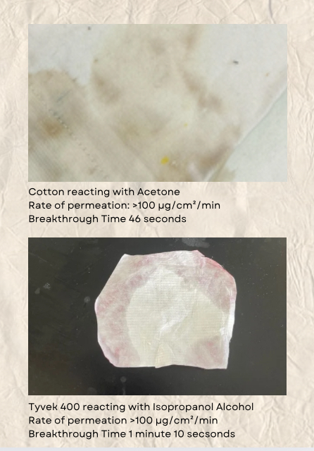

ADDITIONAL OBSERVATIONS & ANALYSIS
• Protection is only surface-level and wears off over time.
• Chemicals can still seep through, particularly with longer exposure durations.
• The tested fabrics are not designed for durability or advanced safety and show clear limitations in maintaining chemical resistance after repeated use or washing.

